Template
Visitor Survey
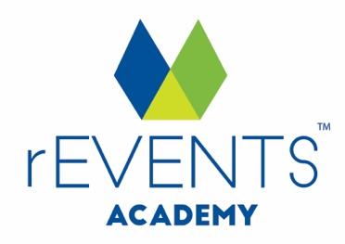
IMPORTANT: Copyright Notice
Except as permitted under the Copyright Act 1968 (Cth), you are not permitted to copy, reproduce, republish, distribute or display any of the information on our website or in our toolkits and resources without our prior written permission.
rEVENTS Academy maintains the copyright on all graphics, images, layouts, text, logos and trademarks contained within our website and toolkits. This includes following any removal of rEVENTS Academy branding and copyright notices for customisation of this document.
For our full terms and conditions go to www.reventsacademy.com

DISCLAIMER
While all care has been taken in the preparation of this material, no responsibility is accepted by the author for any errors, omissions or inaccuracies. The material provided in this checklist has been prepared to provide general information only. It is not intended to be relied upon or be a substitute for legal or other professional advice. No responsibility can be accepted by the author for any known or unknown consequences that may result from reliance on any information provided in this publication.

[Your Event] Visitor Survey

Thank you for joining us at this year’s [Your Event]!
To ensure the community and committee can continually improve and grow the event, we invite you to provide feedback on your experience via our quick survey.

1. What is your gender?
Male Female Otherwise identifying

2. What is your age?
Under 17
18-25
26-35
36-45
46-55
56-65
Over 66

3. Where do you normally live?
Town
State
Postcode
Country (if outside Australia)

4. Did you travel to [your town] specifically to attend [Your Event]?
Yes No

If no, did you extend your stay in [your town] to attend [Your Event]?
Yes No

5. How many nights in total did you spend in [your town] on this trip?
0 (Resident or day-tripper)
1
2
3
4 or more

6. If visiting, how many nights did you spend in other parts of [your state] during this trip?

7. How much money did you spend in total in [your town] during this trip, both for yourself and for other people travelling with you?
Food and drink:
Accommodation:
Transport:
Tickets:
Attractions:
Retail purchases:

8. Who did you attend the event with?
Alone
Friend/s
Partner
Young family (children aged 12 and under)
Older family (children aged 13 and over)
Social, community or sporting group

9. What did you enjoy most about this year’s event?

10. What elements of the event do you think can be improved in the future and how?

11. Please take the time to write a short testimonial about [Your Event] to be used in the future for marketing/promotional purposes

12. Thank you for completing our survey. If you would like to be informed about the event in the future, please enter your email address below

Tip: [delete from this survey before using]
Consider a prize or incentive to encourage visitors to complete your survey.

